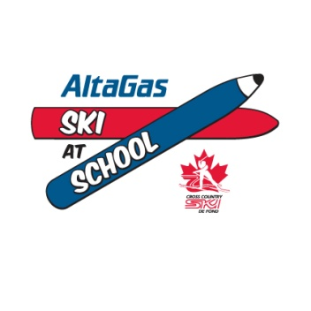
Ski-at-School program grant application

Application deadline: May 29, 2016 (forward by e-mail to skiatschool@cccski.com)

Program description:
The CCC Ski-at-School program powered by AltaGas is aimed at integrating cross-country skiing into the curriculum of elementary and secondary schools across Canada. A Ski-at-School program may be delivered during regular class hours or after school, onsite or nearby, with the support of a local ski club, or as a stand-alone program.

To assist CCC registered clubs and/or schools with starting up and delivering such programs, CCC and AltaGas will provide one-time grants to the most promising projects submitted. Individual grants may reach up to $7500 per program, but cannot represent more than 50% of the program’s budget. Guidelines for delivering a successful Ski-at-School program and examples of age appropriate lesson plans and progression are available to all Ski-at-School programs.

CCC-AltaGas grants may be used for purchasing equipment, transportation of children to a cross country ski facility, grooming on the school premises, coaching or any other relevant operating expenses.

Please use the space below to detail out as much of your plans as possible for bringing the Ski-at-School program into a school or several schools in your area.

Section 1: Contact Details.
Name of applicant (school or club)
Name of respondent
Contact info for respondent (email and phone)
Mailing address of school or club
Website address
Phone number
Section 2: Commitment. Please state why you are interested in developing a Ski-at-School program at your school/club.

Section 3: Description of proposed program.
Anticipated start and end date
Number of sessions (also indicate frequency)
Who will provide coaches (level of certification of coaches)
Number of children targeted per grade and # of coaches involved
Who will provide ski equipment
On what site will the program be delivered (at school and /or nearby ski facility)
Who will manage grooming

Section 4: Draft Budget.
EXPENSES
Ski Equipment (# of kits x $/per kit)
Other materials and equipment (please detail)
Coaching (# of coaches x # of sessions x # hours)
Administration (please detail)
Transportation (please detail)
Grooming equipment/service/fuel
Ski waxing/maintenance
Venue rental
Other (please detail)
REVENUES
Expected CCC-AltaGas grant
Fee paid by school (if applicable)
Fee paid by participants (if applicable)
Club contribution (if applicable)
In kind contributions of labour etc
Other grants( Division, school board)
Donation (if applicable)
Other (please detail)

Section 5: Promotion. Please detail out as much as possible or append a schedule
Medium | Timeline and frequency
Website/Newsletters/Email/Posters
Videos and photos
Vehicle branding (decals)
Apparel, incentives
Other

Section 6: Legacy. Please describe the long-term objectives of your project, how you see the program evolving or growing in the next few years, and what result you wish to achieve.
Please outline your yearly goals and a plan to achieve them:
Year 1 goals:

Year 2 goals:

Year 3 goals:

