RETURN TO SPORT PLAN – CROSS COUNTRY BC
June 3, 2020

Dear Cross Country BC member,

As British Columbia public health authorities develop guidelines to lift some restrictions on gathering in a responsible way, Cross Country BC has been working with viaSport and the Province of British Columbia to understand the recommendations of our Chief Provincial Health Officer and how they best apply within sport.

The attached Return to Sport Plan has been developed for our sport in order to ensure:
- health and safety of all individuals is a priority
- activities are in alignment with provincial health recommendations
- modifications to activities are in place in order to reduce the risks to each sport organization and its participants
- our sport is united and aligned on a plan to reopen throughout the province

While we do hope things will return to normal in the not too distant future, currently this Return to Sport Plan will be the new normal until we are advised otherwise by public health authorities.

If you choose to participate, you must follow these rules:
- If you don’t feel well or are displaying symptoms of COVID-19, you must stay home.
- If you have traveled outside of Canada, you must self-isolate for a minimum of 14 days.
- If you live in a household with someone who has COVID-19 or is showing symptoms of COVID-9, please stay home.
- Wash your hands before participating
- Bring your own equipment, water bottle and hand sanitizer
- Comply with physical distancing measures at all times
- Avoid physical contact with others, including shaking hands, high fives, etc.
- Leave the field of play as quickly as possible after you finish

Our Return to Sport Plan is based on current public health guidance. While we are all doing our best to minimize the risk of exposure to COVID-19, while the virus circulates in our communities it is impossible to completely eliminate the risk. Each participant must make their own decision as to whether it is in their best interest to resume participation at this time. You must take into account your own circumstances and make the decision that is right for you. Should you choose to join us, we require your full cooperation with our Return to Sport Plan.

Sincerely,

Cross Country BC

RETURN TO SPORT – CROSS COUNTRY BC
Background:

- Return to Sport (RTS) definition (from viaSport BC): Return to Sport refers to the process of developing and implementing guidelines for sport organizations to operate safely in B.C. during this pandemic. Return to Sport Plans will be unique to each sport and must follow Provincial Health Office orders and recommendations. One set of guidelines will be created for each sport by its respective Provincial Sport Organization (PSO), and the PSO and affiliated club sanctioned activities should follow this set of guidelines.
- COVID-19 Safety Plan: All organizations in BC (including clubs) must develop and post a COVID-19 Safety Plan, as per the Provincial Health Officer. Clubs can adapt Cross Country BC’s to suit their own needs. viaSport has also provided a useful checklist (pgs. 35+).
- Cross Country BC’s RTS & COVID-19 Safety Plan (CCBC’s “Plan”) specifically targets the Province of British Columbia’s Phase 2 (i.e., now until approximately September) as well as the “off-season” in general so that we can safely “restart” our off-season as quickly as possible, without getting slowed down by winter details/uncertainties. This Plan will be updated as needed.
- Our sport is fortunate in that this period is generally the quietest for clubs, and that for activities that do occur (e.g., group dryland training), modifications are relatively straightforward.
- The Plan addresses the following group activities only for now:
  - Group training
  - Workshops/Courses
  - Office work
- For club activities outside of the above (e.g., summer work bees), it may be simplest to wait until Phase 2 is over. Regardless, clubs can adapt CCBC’s Plan as their situation warrants, but it should align with viaSport’s Return to Sport Guidelines, particularly the Safety Plan checklist on Pg. 35+. Note that neither Cross Country BC nor viaSport needs to subsequently approve club plans. It must be recognized that clubs have very different and unique situations (e.g., some do not manage/maintain their own facilities, some have extremely limited facilities, some have landowner complexities, etc.).
- It is expected that the Province of British Columbia’s guidelines will gradually loosen, but there is no explicit timeline on this yet. To see the framework around future phases, refer to the generic Sport Activity Chart from viaSport in Appendix A. For further info and resources, see the viaSport Return to Sport Guidelines.

For clubs (off-season activity):
- viaSport strongly recommends that 1) clubs acknowledge the risks of restarting, 2) clubs align with CCBC’s Plan, and 3) club boards approve their club’s COVID-19 Safety Plan.
- The plan should be posted (e.g., on club websites) and reviewed with relevant staff/volunteers/participants.
- Participants in club-directed activities should be asked to complete a Participant Agreement acknowledging their acceptance of the risks. (See sample on pg. 31). CCBC has created an online Participant Agreement that may suit your needs. (Registrant names are public.)
- Relevant staff, coaches, volunteers and participants should complete the online Self-Assessment Tool on a daily basis when participating in group activities. Link: https://bc.thrive.health/covid19/en

RETURN TO SPORT & COVID-19 SAFETY PLAN – CROSS COUNTRY BC
CCBC-directed off-season group activity can now resume, under the conditions below. We will monitor the situation and make changes as necessary.

General Rules

For all individuals and for all activities (training, workshops, office work, etc.), if you choose to participate, you must follow these rules:
- If you don’t feel well or are displaying symptoms of COVID-19, you must stay home.
- If you have traveled outside of Canada, you must self-isolate for a minimum of 14 days.
- If you live in a household with someone who has COVID-19 or is showing symptoms of COVID-19, please stay home.
- Wash your hands before participating
- Bring your own equipment, water bottle and hand sanitizer
- Comply with physical distancing measures at all time
- Avoid physical contact with others, including shaking hands, high fives, etc.
- Leave the field of play or facility as quickly as possible after you finish

Furthermore:
- All individuals have signed the online Participant Agreement acknowledging their acceptance of the risks.
- All individuals have completed the online self-assessment tool, on a daily basis before arriving.
- Coaches and administrators are familiar with the Illness Policy (see Appendix B).
- Consider your own risk. If you are at higher risk of experiencing serious illness from COVID-19, consider limiting or avoiding participation for the time being.
- If you start to feel mildly ill while participating, inform the person in charge (e.g., coach), sanitize your hands, go straight home, and complete the online self-assessment tool. If severely ill (e.g., difficulty breathing, chest pain) have the person call 911. (And that person should ensure the cleaning and disinfecting of any surfaces that you have come into contact with.)
- If you have any health and safety concerns, inform the person in charge and/or the CCBC office.

Group Training (including camps)

- In addition to below, comply with above General Rules.
- Coaches are to remind all participants of the rules at the beginning of each day.
- Outdoors is best and activities are structured so physical distancing is maintained (2m). Increase distance with higher speed training activities (e.g., roller skiing, running). When possible & safe, it is preferable to run/bike/ski BESIDE others instead of BEHIND (e.g., on closed roads, wide trails).
- Maximum group size is 50, but realistically needs to be smaller for effective/safe group training.
- If indoor facilities are used (e.g., gym), follow all additional facility directives in place.
- Athletes should only travel by themselves or with members of their household.
- Parking is limited to every second slot to allow for physical distancing.
- A record of participants is maintained.
- “Get in, Train, Get out.” Athletes arrive ready to go and do not mingle with the group upon arrival or departure.
- Nothing is shared. If something must be shared (e.g., surfaces), it is cleaned/disinfected between users (e.g., with disinfecting wipes). Assign one individual to read the info on cleaning and disinfectants and to do the disinfecting.
- Car shuttles (e.g., roller ski hill workouts) are not used during training sessions.
- Overnight camps are avoided unless living arrangements, ground transportation, and meals can be structured to follow health and safety protocols.
- Avoid cross-regional or inter-provincial travel.
- For dryland time-trials or races, use individual start only. Timing chips or bibs shall not be shared, but may be used if owned by / permanently assigned to the athlete.
- Sanitation supplies are available as needed.
- Masks and gloves are available in case first-aid is required. Coaches have trained themselves on the proper use of masks.
- Coaches should ensure adequate supervision so that rules are followed, with reminders as needed.

Workshops/Courses

Background: Workshops/Courses typically have between 6 and 12 adult participants.

- In addition to below, comply with above General Rules.
- Learning facilitators or course conductors are to remind all participants of the rules at the beginning of each day.
- Ensure room and tables are set-up so that physical distancing is maintained (2m).
- Assign one individual to read the info on cleaning and disinfectants and then to disinfect (e.g., using disinfecting wipes)
  - each workspace before starting;
  - all common touchpoints (e.g., door handles, light switches) at least twice per day.
- Ensure there is adequate sanitizer in washroom.
- Follow any additional facility directives.
- A record of participants is maintained.
- Do not share any equipment.

Offices

- In addition to below, comply with above General Rules.
- The Employer is to remind all staff of the rules.
- Ensure workspaces are set-up so that physical distancing is maintained (2m) or that barriers are adequate (e.g., cubicle walls).
- Ensure there is sanitizer available at each common touchpoint (e.g., by office door, by photocopier).
- Assign one individual to read the info on cleaning and disinfectants and then to disinfect (e.g., using disinfecting wipes) all common touchpoints (e.g., door handles, light switches, photocopier) at least twice per day.
- Ensure there is adequate sanitizer in washroom.
- Follow any additional facility directives, if any.
- Do not share any equipment if possible.
- Work and meet virtually where possible.
First Aid

In the event that first aid is required to be administered during an activity, all persons attending to the injured individual must first put on a mask and gloves.

A guide for employers and Occupational First Aid Attendants: https://www.worksafebc.com/en/resources/health-safety/information-sheets/ofaa-protocols-covid-19-pandemic?lang=en
First aid protocols for an unresponsive person during COVID-19: https://www.redcross.ca/training-and-certification/first-aid-tips-and-resources/first-aid-tips/first-aid-protocols-for-an-unresponsive-person-during-covid-19

Outbreak Plan

If any individual reports they are suspected or confirmed to have COVID-19 and have been at the workplace/activity place, inform the Coach and/or CCBC office. They will then execute the Outbreak Plan (pg. 20) provided by viaSport BC.

APPENDIX A - SPORT ACTIVITY CHART - from viaSport BC

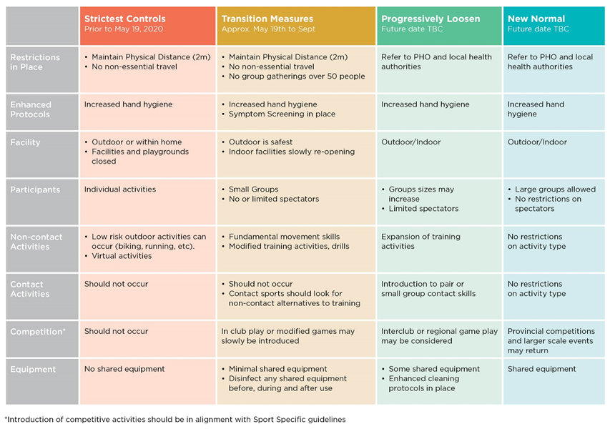

APPENDIX B – ILLNESS POLICY

In this policy, “Team member” includes an employee, coach, volunteer, participant or parent/spectator.

- Inform an individual in a position of authority (e.g., coach) immediately if, you feel any symptoms of COVID-19 such as fever, chills, cough, shortness of breath, sore throat and painful swallowing, stuffy or runny nose, loss of sense of smell, headache, muscle aches, fatigue and loss of appetite.
- Assessment
  - Team members must complete the online self-assessment tool each morning before their activity to attest that they are not feeling any of the COVID 19 symptoms.
  - Coaches will visually monitor team members to assess any early warning signs as to the status of their health and to touch base on how they are regarding their personal safety throughout the activity.
- If a Team Member is feeling sick with COVID-19 symptoms
  - They should remain at home and contact Health Link BC at 8-1-1.
  - If they feel sick and /or are showing symptoms during the activity, they should be sent home immediately and have them contact 8-1-1 or a doctor for further guidance.
  - No Team Member may participate in an activity if they are symptomatic.
- If a Team Member tests positive for COVID-19
  - The Team Member will not be permitted to return to the workplace/practice/facility until they are free of the COVID-19 virus.
  - Any Team Members who work/play closely with the infected Team Member will also be removed from the workplace/practice/facility for at least 14 days to ensure the infection does not spread further.
  - Close off, clean and disinfect their work/practice/facility area immediately and any surfaces that could have potentially be infected/touched.
- If a Team Member has been tested and is waiting for the results of a COVID-19 Test
  - As with the confirmed case, the Team Member must be removed from the workplace/practice/facility.
  - The Public Health Agency of Canada advises that any person who has even mild symptoms to stay home and call the public health authority of B.C.
  - Other Team Members who may have been exposed will be informed and removed from the workplace/practice/activity for at least 14 days or until the diagnosis of COVID-19 is ruled out by health authorities.
  - The workspace/practice/activity space will be closed off, cleaned, and disinfected immediately and any other surfaces that could have potentially been infected/touched.
- If a Team Member has come in to contact with someone who is confirmed to have COVID-19
  - Team Members must advise their employer/coach if they reasonably believe they have been exposed to COVID-19.
  - Once the contact is confirmed, the Team Member will be removed from the workplace/practice/activity for at least 14 days or as otherwise directed by public health authorities. Team Members who may have come into close contact with the Team Member will also be removed from the workplace for at least 14 days.
  - The workspace/activity area will be closed off, cleaned, and disinfected immediately and any other surfaces that could have potentially been infected/touched.
- Quarantine or Self-Isolate:
  - Any Team Member who has travelled outside of Canada or the province within the last 14 days is not permitted to enter any part of the facility and must quarantine and self-isolate.
  - Any Team Member with any symptoms of COVID-19 is not permitted to enter any part of the facility and must quarantine and self-isolate.
  - Any Team Member from a household with someone showing symptoms of COVID-19 is not permitted to enter any part of the facility and must quarantine and self-isolate.
  - Any Team Member who is in quarantine or self-isolating as a result of contact with an infected person or in families who are self-isolating, is not permitted to enter any part of the facility.

